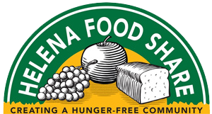

FOR IMMEDIATE RELEASE:

Contact: Bruce Day, Executive Director
Phone: 406-443-3663, ext. 108
Email: bruced@helenafoodshare.org

Food Available at Helena Food Share for Displaced North Hills Fire Residents
Local Food Pantry Open to People Affected by Fire

Helena, Montana, July 29, 2019: Helena Food Share announced this morning that they stand ready to assist individuals and families who have been displaced by the North Hills fire and need food.
Helena Food Share Executive Director Bruce Day said, “We want to extend help to those who have been affected by the North Hills fire. If anyone needs food assistance, we are here and we can help.”

Day noted the following steps that people can take if they need food:

- Visit the pantry during operating hours with a picture ID. Helena Food Share does not require any type of income verification.
- Check in at the front desk and complete a short intake form. All information will be kept confidential.
- A volunteer will explain how to shop the pantry. Grab a cart, a shopping list (based on family size) and start choosing food to nourish your family.

Lewis Street Pantry
1616 Lewis Street
Helena, MT 59601
(406) 443-3663
Monday, 12:30 p.m.-6:00 p.m.
Tuesday-Friday, 12:30 p.m.-3:30 p.m.

For more information or assistance, call 406-443-3663.

Helena Food Share|P.O. Box 943|Helena, MT 59624|www.helenafoodshare.org

