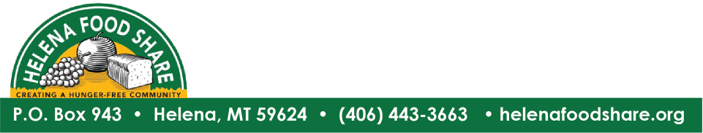

FOR IMMEDIATE RELEASE:

Contact: Heidi O’Brien,
Communications Manager/Helena Food Share
Office 406-443-3663 ext. 105
Cell 406-465-2938
heidi@helenafoodshare.org
Helena Food Share Launches Kid Pack Challenge on September 11th at Bryant School

Seeks Donations to Help Fund Annual Kid Pack Program

HELENA, MT: September 9, 2019: Helena Food Share is launching the 10th annual Kid Pack Challenge fundraiser on September 11th. The Challenge raises $175,000 needed to provide 1,100 supplemental food packs to Helena-area children each week who are at risk of weekend hunger.

Kid Packs are distributed each Friday of the school year to children who are at risk of hunger over the weekend. They include nutritious, kid-friendly food items such as oatmeal, ravioli meals, low-sugar fruit cups and granola bars.

The fundraising event will be preceded by a 3:30pm parade from the Helena Food Share pantry to Bryant Elementary School. Each person in the parade will be carrying Kid Packs that will be given to Bryant School students on Friday.

The fundraising event will start at 4:00 pm as the parade arrives at Bryant School. Attendees will hear from special guest speakers including Montana’s First Lady Lisa Bullock, Helena School Superintendent Tyler Ream, and Bruce Day, the executive director of Helena Food Share. Additionally, First Interstate Bank Helena President Brenden Craig will present a $20,000 check to Helena Food Share to kick off the fundraising campaign, and will be offering an additional $2,500 match for all donations made at the event.

Helena Food Share Executive Director, Bruce Day said, “It is only with the generous support of the Helena community that this effort has continued for so many years. We are grateful to the many sponsors of this fundraiser, especially First Interstate Bank, their employees and the First Interstate Bank Foundation for their continuing, and major, contributions to helping stop child hunger in Helena.

First Interstate Bank Helena President Brenden Craig said, “We’re proud to support the Helena Food Share and organizations like it who give and give generously to make our community a better place to live, work, and raise a family.”

Anyone unable to attend the event who would like to support Helena Food Share’s Kid Pack program, may donate online at helenafoodshare.org/donate or by calling 443-3663, ext. 104.

The Parade, 3:30pm
Meet at Helena Food Share at 1616 Lewis Street promptly at 3:30pm
Gather some Kid Packs and a balloon
Walk three blocks to Bryant Elementary School and stay for the ceremony

Event Details: 4-5pm
Join other Food Share supporters at Bryant Elementary School, 1520 Livingston Avenue.
Food and beverages will be served.
Guest Speakers include First Lady Lisa Bullock, Helena School Superintendent Tyler Beam, Bryant School Principal Trisha Klock
Donations will be accepted at the event.

###

